1 .select *from participated order by damage_amount asc;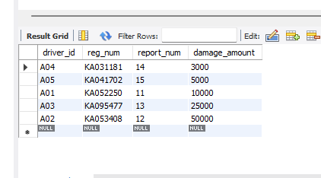

2.select max(damage_amount) from participated;

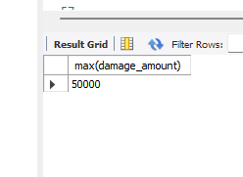

3.

.select name from person

where driver_id in (select driver_id from participated

where damage_amount >(select avg(damage_amount) from participated));



4.select max(damage_amount) from participated;

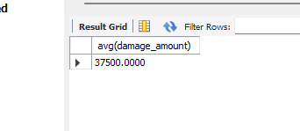

5.delete from participated

where damage_amount <(select t.amount from (select avg(damage_amount) as amount from participated) t);

SELECT * FROM PARTICIPATED;

